Trustee Role Application Pack

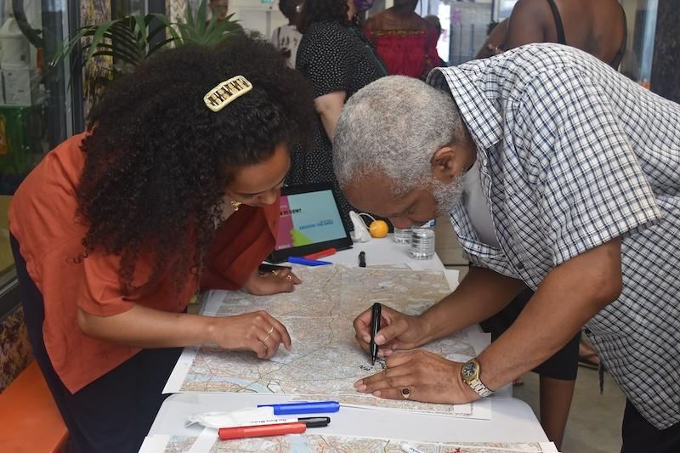
Emotional Mapping exercise with Resolve Collective, 2021. Image by Sadé Elufowoju.

Background Information:

Peckham Platform is a cultural organisation with a civic duty. Our vision is of a more connected society and we are dedicated to creating positive change through meaningful social art, delivering projects where local communities and artists work together at each stage to provide a programme that is uniquely responsive and relevant to place. Since 2010, we have fostered new collaborations between our local communities and prominent social artists; to co-produce bold new artworks that create open platforms for civic enquiry.
In 2023, we will launch our new venue on Peckham Square, working in partnership with London Borough of Southwark. Our new home will be at the heart of an ambitious new vision for Peckham Platform. With five times our previous footprint and new facilities; we will become a welcoming centre for creative civic engagement and community participation. With new gallery spaces, learning facilities, and a dedicated Social Art Resource we will expand our activities, doubling our audiences, the number of participation opportunities we offer, and increasing our ability to create transformational artistic opportunities for communities facing the greatest need in Peckham and beyond.

We operate in Peckham, with 71% BAME* local residents and over 40% young people - one of the highest ratios in the country. Peckham is changing rapidly, with a borough-led strategy for regeneration providing significant investment in the area in recent years and new businesses and communities moving to Peckham. Within this, a cultural scene is burgeoning, with outstanding cultural spaces and innovative creative industries emerging.
Inequality is growing, existing communities are being displaced and marginalised, and the benefit of new investment is often being felt only by a narrow cross-section of residents. Lower overall deprivation masks the continuing challenges facing Peckham, which is historically one of the most deprived areas in the country; 84% of the population live in the most economically challenged quintile nationally; 34% of children live in low income households; unemployment is at 15%; and it is ranked in the 12% highest crime spots in England. The situation has become critical in the context of sweeping cuts to public services decimating Peckham’s support structures.
This inequality of access and opportunity is becoming even more apparent in Peckham at this time of rapid development. Operating within this complex landscape of urban change, Peckham Platform is committed to addressing social inequalities, promoting cultural democracy, and initiating long-term relationships with the arts across communities of need. Young people are at the heart of this process, as collaborators and audiences. Through our learning programmes, we use creative practice to explore alternative pedagogies that place young people at the centre of their educational development.
Our mission is more important than ever as we face a national crisis that spans social, environmental, economic, political and cultural fields. In this challenging context, the social value of art is being given more attention. Cultural organisations are increasingly experimenting with delivering more socially relevant work and look to Peckham Platform as a model of best practice. Our new venue is essential to helping us to expand our work to meet the needs of our community and the sector.
We believe that Peckham’s public spaces can be reclaimed by residents as welcoming areas to come together; reinvigorated through performances, exhibitions, artistic interventions, and more. Our locality’s vibrancy will be celebrated, recognising the diversity of experiences and histories that contribute to Peckham's unique identity, equally.
*BAME is a problematic term and we agree with its many critics within the sector and beyond. We use this term here as a reminder that this term remains in use in “official” data such as the census.

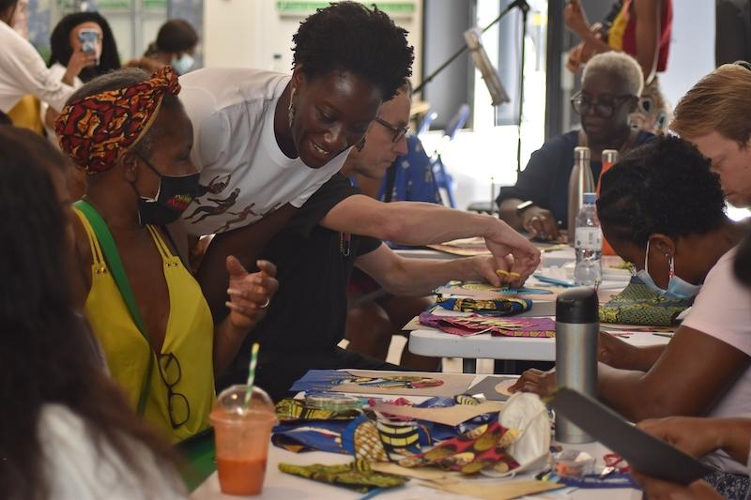
Attendees of Birungi Kawooya’s Mindful African Art Class, 2021. Image by Sadé Elufowoju.

Artistic Programme
Our artistic programme strives to be both relevant and supportive to artists and the communities with whom we work. Reflecting our values and concerns as a cultural organisation with a civic duty. We are committed to community-led co-commissioning and creating a genuinely collaborative process.
For each commission, we focus our work on engaging communities that are at risk of being marginalized in the cultural mainstream, platforming groups to explore the issues that arise with them. In the past, this has amplified the voices of womens’ youth services, disability, mental health, and substance abuse recovery groups. We maintain a joint decision-making process with communities right through to the exhibition, installation or event.
Our new home will provide a larger, redeveloped gallery that welcomes these communities and more to a permanent and resilient home for our ground-breaking work, building on 10 years at the forefront of social art.
Our current co-commissioning programme includes a three-year project funded by Catalouse Gulbenkian Foundation, Esmée Fairbairn and Big Lottery titled Create Civic Change. A cross-generational, cross-cultural project capturing our community’s response to a rapidly changing Peckham.

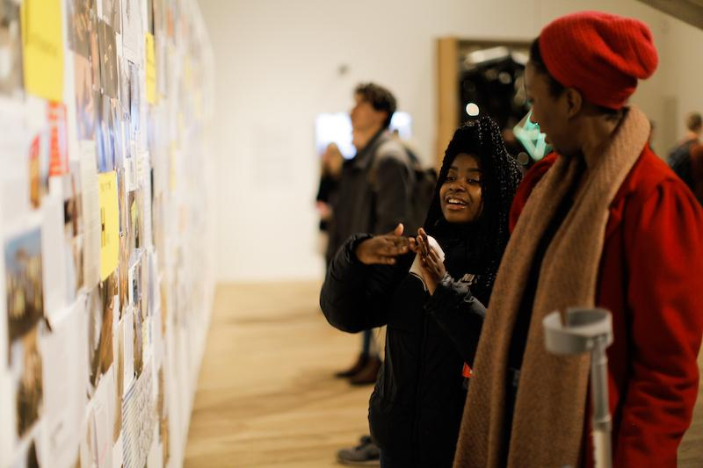
Visit to Tate Modern led by artist Beverley Bennett with Leaders of Tomorrow and Peckham Park Baptist Church Youth Group, 2019. Image: Ruth Sewell.
Learning Programme
Our work with young people currently includes Arts Awards and Youth Platform, a creative in-house initiative that develops agency in young people facing multiple factors of disadvantage in Peckham. Funded by Charterhouse Southwark and the Portal Trust, in the last 3 years, we have nurtured an effective model of progressive participation, from often first out of school arts engagement, to becoming creative leaders with the skills and confidence to pursue pathways in the creative sectors. This work will be central to our organisational growth moving forwards. The learning programme is currently going through a development process to increase our offer for more people across the ages.

"Peckham Platform has proven itself to be a shining beacon in bringing together artists’ practices and community interest to embed contemporary art in a great unfolding programme of productive dialogues in London" Sonia Boyce, MBE, Artist

Company Information
Peckham Platform is a registered charity and company limited by guarantee. Its annual turnover is around £380,000 with over 20% of its budget allocated to artistic programme. A National Portfolio Organisation of Arts Council England (receiving £75k pa), the organisation relies on fundraising and commercial income generation to deliver its creative and business plans.

Peckham Platform has a core staff of 6 with a further people working on project funded contracts, equating to a team of four as a full time equivalent. We are committed to creating a diverse workforce, offering flexibility within employment contracts, widening access to careers in the arts for volunteers, interns, apprentices and placements, and ensuring all staff have personal development plans to enable them to progress their career.

The Board of Trustees consists of eleven members who oversee the Charity and support the organisation in many ways. Trustees each bring unique skills to the organisation and contribute to the success of Peckham Platform.

Role Description

Role Title: Trustee / Business Development & Governance

Salary: Voluntary position

Accountable to: Chair of Board of Trustees
Location: Quay House, 2c King's Grove, Peckham, London SE15 2NB

Areas of expertise:

- Business development and Governance, Leadership and Finance

Scope of Role:
We are seeking to grow and diversify our skills set as a team of committed people, at a time of significant change and growth. As a new Peckham Platform Trustee, you will have the opportunity to make a real impact on the organization as we move into our new building in 2023.

We are seeking a trustee who are able to:

- Actively advocate for Peckham Platform using their network to access new partnerships and support
- Offer strategic oversight of our Capital Project opening in 2023
- Effectively input on risk management and providing strategic advice on finance
- Support on the development of Partnerships to support our Capital project
- Take part in shaping new innovative solutions and opportunities to raise income in a time of change
- Input on review of policies on a yearly basis to ensure they are effective, anti-racist, and anti-discriminatory on multiple levels.
- Promote respect, self-care and positive well-being as central to the work of dismantling racism.

Skills, Knowledge and Experience

- A keen interest, knowledge and awareness of the work of Peckham Platform
- Ability to objectively evaluate, analyse and scrutinize information relating to the charity.
- Ability to build positive relationships and networks over time to develop and grow our network with stakeholders
- Ability to work co-operatively and collaboratively with other Trustees and staff
- Knowledge and experience of Charity finance
- Extensive network and influencing skills
- Significant track record in change management, strategic development, business planning and capital project management
- Knowledge in HR is desired but not essential
- An understanding of - or willingness to learn about - the legal duties, responsibilities and liabilities of trusteeship
- An understanding of - or willingness to learn about - governance policies and procedures
- An understanding of our local communities and of the social, economic and political challenges facing Peckham and Southwark.
- Willingness to learn about Arts Council England’s Strategy and Investment Principles including ACE’s ‘Creative Case for Diversity’

- Understanding of public funding and the Board’s duty to ensure proper records are kept, controlled and invested in line with governance, legal and regulatory requirements
- Ability to undertake a DBS check for safeguarding purposes

Previous trustee experience is not essential, we are keen to support applicants from a variety of diverse backgrounds to develop their skills and to proactively support and mentor new trustees.

We are unable to take applications from individuals who fall into the categories described in sections 178 to 180 of the Charities Act 2011. This includes:

- Anyone who has an unspent conviction for an offence involving deception or dishonesty;
- Anyone who is an undischarged bankrupt;
- Anyone who has been removed from trusteeship of a charity by the Court or the commission for misconduct or mismanagement;
- Anyone under a disqualification order under the Company Directors Disqualification Act 1986;
- Anyone who has entered into a composition or arrangement with their creditors which includes an individual voluntary arrangement (IVA), and is currently on the Insolvency Service Register.

Time commitment and remuneration

The Trusteeship is an unpaid role however all reasonable expenses incurred by Trustees will be reimbursed so that no individual is out of pocket as a result of their involvement with the charity. This includes reasonable cost of travelling to and from trustee meetings, cost of childcare while attending trustee meetings and to facilitate reasonable adjustments for a trustee with a disability.

We do ask for a commitment to attend around 8-12 days a year to the business of the charity, including board meetings, committees and training. All trustees are encouraged to sit on or Chair a sub-committee relevant to their area of expertise. Trustees serve a maximum of two three-year terms from the date of appointment. After this time trustees step down for a minimum of one year before being eligible to stand for re-election.

For further information on trustee responsibilities please read the Governance Code: https://www.charitygovernancecode.org/en/front-page

How to apply

You are welcome to call us for more information and to discuss the role and what we do. Please email Peckham Platform’s Executive Director, Karin at karin@peckhamplatform.com

To apply to become a member of the Board of Trustees for Peckham Platform, please forward an up-to-date CV together with a supporting statement explaining how your skills and experience match the requirements of the role to: recruitment@peckhamplatform.com

Deadline: Monday 22nd November 2021

Please also provide the names, positions, organisations and telephone contact numbers of two referees. References will only be taken once your express permission has been granted.

You are also invited to complete and return the enclosed diversity monitoring form. The information on the form will be treated as confidential, and used for statistical purposes. The form will not be treated as part of the application.

